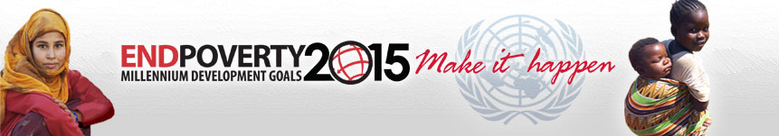

PARTNERSHIP EVENTS

This form serves to provide information on partnership events around the 25 September High-Level Event on the Millennium Development Goals. The information will be posted on the UN website for the High-Level Event in order to capture all planned partnership events, encourage a coordinated approach, share information among partners and with the public, and better communicate the results of the events as an important element of the outcome of the High-Level Event. To do so meaningfully, it is important that the data provided is complete and follows the format outlined below. Organizers (one form per event) are very much encouraged to use this standard form when reporting. Organizers are also encouraged to report immediately once information is available and to send updates as and when necessary to provide further information.

1. Partnership Event Information

Organizers
Name and Details of Key Contact
Public contact/website
Event Title
Date and Time
Location
Format
Participants
Objectives/Purpose
Open to media
2. Expected Outcomes and Commitments for the MDGs

Expected Outcomes
Expected Commitment
Time Period/Date of delivery
Expected Impact on Specific MDGs
Monitoring and Evaluation
Media involvement
Other relevant information

Event Details will be published on the MDG High-Level Event website:
http://www.un.org/milleniumgoals/2008highlevel

Please transmit the form to For further questions please contact
UN Office for Partnerships UN Office for Partnerships
fax : +1-212-963-1486 Ms. Constanze Westervoss
email: partner@un.org Westervoss@un.org
Tel.: 212-963-1576

Please indicate a contact person. This information will not be made public, unless requested.
Please note the expected outcomes will be captured in a summary report and will be posted after the event has taken place, unless otherwise requested.
Please use additional copies of this page if more than one outcome is expected.

